Graduate Visa (Subclass 485)-STANDARD OPERATING PROCEDURE

Document Control
Document No. | SOP-ESP-001
Version | 1.0
Department | Migration Services
Effective Date | ________________
Approved By | ________________

Purpose
This Standard Operating Procedure (SOP) establishes a consistent, efficient and compliant process for managing Graduate Visa (Subclass 485) applications from the initial client enquiry through to the final visa outcome.

2. Scope
This procedure applies to all Graduate Visa (Subclass 485) applications handled by Yale Migration.
The SOP covers:
- Initial enquiries
- Eligibility assessment
- Client engagement
- Document collection
- Visa preparation
- Visa lodgement
- Post-lodgment monitoring
- Visa outcome management

3. Roles and Responsibilities

3.1 Registered Migration Agent
- Assess eligibility and migration risks.
- Provide migration advice and conduct consultations.
- Conduct final quality assurance before lodgment.
- Lodge applications through Immi Account.
- Monitor applications and respond to Department requests.

3.2 Consultant
- Respond to enquiries and collect preliminary information.
- Prepare quotations, Service Agreement and checklists.
- Collect, organize and save client documents.
- Prepare visa draft and supporting documents.
- Coordinate client review.
- Monitor application progress and communicate updates.
- Prepare invoices and maintain records.

4. Tools and Systems
- ImmiAccount
- Client Management System
- Client Engagement Log
- Secure Cloud Document Storage
- Standard Checklists and Templates
- Email and Microsoft Office / Google Workspace

5. Document Management

Every client must be registered in the Client Engagement Log to generate a Unique Client Code

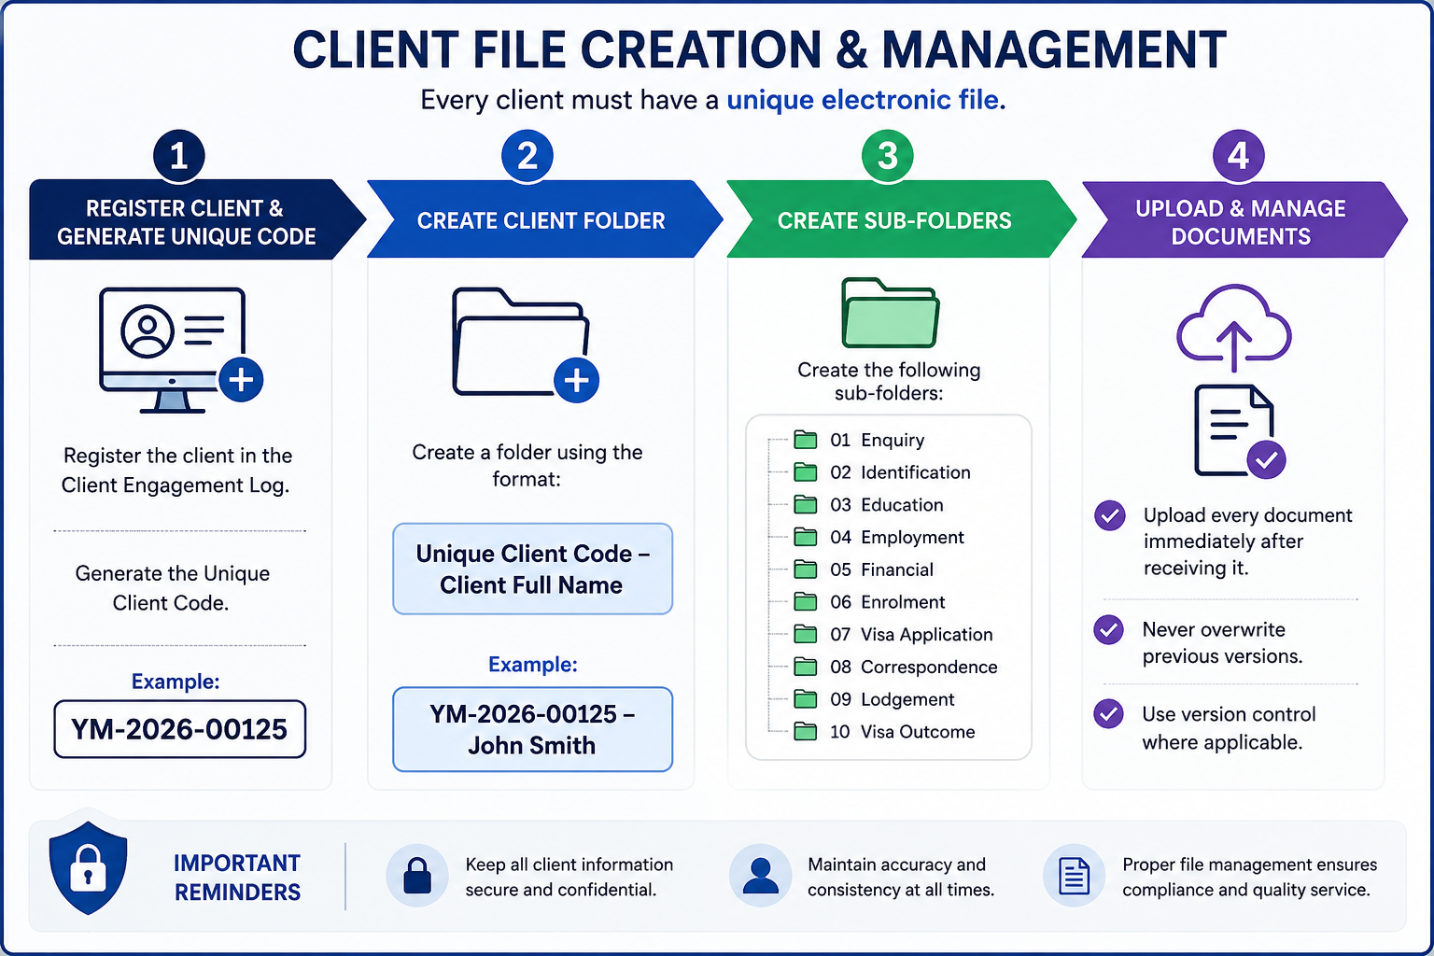
Step | Process | Procedure
1 | Register Client | Register the client in the Client Engagement Log and generate a Unique Client Code.  Example: YM-2026-00125
2 | Create Client Folder | Create a client folder using the following naming convention:  Unique Client Code – Client Full Name  Example: YM-2026-00125 – John Smith
3 | Create Sub-Folders | Create the following folders within the client's main folder:  01. Enquiry  02. Identification  03. Education  04. Employment  05. Financial  06. Enrolment  07. Visa Application  08. Correspondence  09. Lodgement  10. Visa Outcome
4 | Upload & Maintain Documents | Upload all client documents immediately upon receipt.  • Do not overwrite previous versions.  • Apply version control where necessary.  • Ensure all documents are saved in the correct sub-folder.

6. Graduate Visa (Subclass 485) Application Procedure
Step | Process | Responsible | Required Action
1 | Receive Client Enquiry | Consultant | Respond to enquiries received via phone, email, social media or walk-in and provide general information about the Graduate Visa (Subclass 485).
2 | Initial Assessment | Consultant | Request the completed enquiry form, resume/CV, passport, current visa, academic qualifications completed in Australia, and English language test (if available).
3 | Eligibility Assessment | Registered Migration Agent | Assess the client's eligibility and determine whether they qualify under the Post-Higher Education Work Stream or the Post-Vocational Education Work Stream.
4 | Skills Assessment Requirement | Registered Migration Agent / Consultant | If applying under the Post-Vocational Education Work Stream, identify the appropriate occupation and required Skills Assessment authority. Refer to the agency's approved Skills Assessment Reference Guide.
5 | Higher Education Stream | Registered Migration Agent | If the client is applying under the Post-Higher Education Work Stream, confirm that a Skills Assessment is not required (unless otherwise specified under current legislation).
6 | Client Consultation | Registered Migration Agent / Consultant | Explain the visa requirements, eligibility criteria, processing times, visa conditions, English language requirements, fees, and future migration pathway options.
7 | Client Engagement | Consultant | Register the client in the Client Engagement Log, generate the Unique Client Code, create the electronic client folder, and send the quotation, Service Agreement and Graduate Visa Checklist.
8 | Service Agreement & Payment | Consultant | Obtain the signed Service Agreement and confirm receipt of the engagement fee or initial professional fee before commencing work.
9 | Document Collection | Consultant | Collect all documents required for the Skills Assessment (if applicable) and Graduate Visa application, including identity, qualifications, English test results, police clearances, health insurance and supporting documents.
10 | Document Verification & Storage | Consultant | Review all documents for completeness and accuracy, then upload them to the client's electronic folder in accordance with the Document Management Procedure.
11 | Skills Assessment Application (If Required) | Registered Migration Agent | Prepare and lodge the Skills Assessment application with the appropriate assessing authority. Monitor its progress until the outcome is received.
12 | Outstanding Payments | Consultant | Confirm that all professional fees, government charges and third-party fees have been paid before preparing the visa application.
13 | Visa Application Preparation | Consultant | Prepare the Graduate Visa application, complete the ImmiAccount draft, and organise all supporting documents for internal review.
14 | Client Review & Approval | Consultant | Send the completed visa application draft to the client for review and obtain written confirmation that all information is complete and accurate.
15 | Final Review & Visa Lodgement | Registered Migration Agent | Conduct the final quality assurance review and lodge the Graduate Visa application through ImmiAccount.
16 | Update Internal Records | Consultant | Update the Lodgement Register with the lodgement date, Transaction Reference Number (TRN), visa expiry date, and Bridging Visa details (if applicable).
17 | Post-Lodgement Communication | Registered Migration Agent / Consultant | Provide the client with the Visa Lodgement Acknowledgement, Bridging Visa Grant (if applicable), HAP ID and health examination instructions, where required.
18 | Skills Assessment Monitoring (If Pending) | Consultant | Where the Skills Assessment outcome is still pending, closely monitor the application. If the Department issues a Section 56 (s56) Request for Further Information, upload the Skills Assessment outcome immediately upon receipt before the due date.
19 | Application Monitoring | Consultant / Registered Migration Agent | Monitor the Graduate Visa application through ImmiAccount, respond promptly to Department requests, and keep the client informed throughout the assessment process.
20 | Visa Outcome | Consultant / Registered Migration Agent | Notify the client of the visa decision. For visa grants, explain visa conditions and next steps. For refusals, explain the decision and discuss available options where appropriate.
21 | File Closure | Consultant | Save the visa outcome, update all internal records, complete the Client Engagement Log, and archive the client's electronic file in accordance with the agency's record retention policy.

7. Quality Control Checklist
The Registered Migration Agent must complete the following quality assurance checks before lodging any Graduate Visa (Subclass 485) application. No application is to be lodged until all applicable items have been reviewed and confirmed.
Quality Check | Completed (✓)
Client identity has been verified using a valid passport or government-issued identification. | ☐
Passport is valid for the intended visa application period. | ☐
Applicant meets the eligibility requirements for the Graduate Visa (Subclass 485). | ☐
Correct visa stream has been selected (Post-Higher Education Work Stream or Post-Vocational Education Work Stream). | ☐
Australian qualification has been completed and supporting academic documents have been verified. | ☐
Confirmation of course completion, transcript and completion letter have been received (where applicable). | ☐
English language requirement has been met and valid test results have been provided (if applicable). | ☐
Appropriate health insurance (OVHC or other eligible cover) has been arranged for the required visa period. | ☐
AFP National Police Check has been obtained or applied for, where required. | ☐
Skills Assessment has been completed and approved (Post-Vocational Education Work Stream only), or evidence of application has been provided if permitted. | ☐
Genuine supporting documents have been reviewed for completeness, accuracy and consistency. | ☐
Personal information is consistent across all documents and application forms. | ☐
All required declarations and consent forms have been completed and signed. | ☐
Client has reviewed and approved the final visa application before lodgment. | ☐
Visa Application Charge (VAC), professional fees and all applicable third-party costs have been confirmed with the client. | ☐
All supporting documents have been correctly named, organized and saved in the client's electronic folder in accordance with the Document Management Procedure. | ☐
Registered Migration Agent has completed the final compliance review and approved the application for lodgment. | ☐
Visa application has been successfully lodged through Immi Account, and the Transaction Reference Number (TRN) has been recorded. | ☐
Lodgment acknowledgement, Bridging Visa Grant (if applicable), HAP ID and post-lodgment instructions have been sent to the client. | ☐

Important
- Any missing, inconsistent or incomplete information must be resolved before the application is lodged.
- Applications requiring a pending Skills Assessment outcome must be monitored closely. If the Department issues a Section 56 (s56) Request for Further Information, the Skills Assessment outcome must be uploaded before the due date.
- The Registered Migration Agent is responsible for ensuring the application complies with current legislation, Department of Home Affairs policy and professional obligations before lodgment.

8. Compliance and Disclosure
Yale Migration is committed to maintaining the highest standards of professionalism, ethical conduct and compliance with Australian migration legislation.
All staff involved in Graduate Visa applications must comply with the following requirements:

Legislative Compliance
- Comply with all applicable Australian migration legislation, regulations and policy requirements.
- Follow all requirements of the Department of Home Affairs when preparing and lodging visa applications.
- Ensure that all information provided in a visa application is accurate, truthful and supported by appropriate evidence.

Professional Responsibilities
- Only a Registered Migration Agent may provide migration advice or make legal representations regarding visa matters.
- Consultants and administrative staff must not provide migration advice unless authorised to do so.
- Any complex migration issues must be referred to the Registered Migration Agent.

Client Confidentiality
- Protect all client information in accordance with Australian privacy requirements and the agency's privacy policy.
- Client information must only be accessed by authorized staff for legitimate business purposes.
- Client documents must be stored securely within the agency's approved document management system.

Accuracy and Record Management
- Maintain complete, accurate and up-to-date client records always.
- Record all client communications, advice provided, and documents received or submitted.
- Ensure all electronic files follow the agency's document naming and filing procedures.

Fee Disclosure
Before commencing any work, the client must receive clear written information regarding:
- Professional service fees.
- Government Visa Application Charges (VAC).

Client Acknowledgement
Before visa lodgment, the client must acknowledge that:
- All information provided is true, complete and accurate.
- They have reviewed and approved the final visa application.
- They understand their obligations as a Student Visa holder.
- They understand that providing false or misleading information may result in visa refusal or cancellation.

Visa Outcome Disclaimer
Yale Migration will prepare and manage every application with due skill, care and diligence. However, the approval or refusal of any visa application is solely at the discretion of the Department of Home Affairs.
Neither Yale Migration nor the Registered Migration Agent can guarantee the grant of a visa, as each application is assessed on its individual merits and in accordance with Australian migration legislation and policy.

